How system works

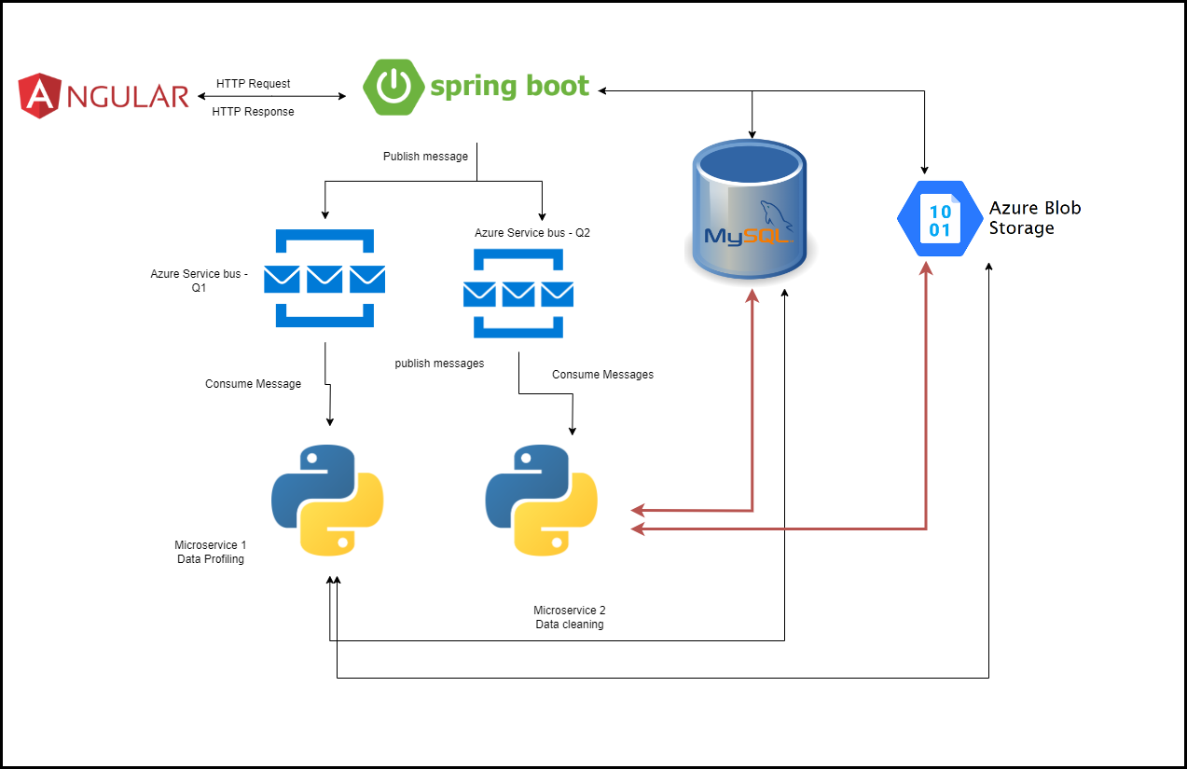

In our application we use Angular for developing front end.

Only view part is handled in Angular

All the business logic will be handles in sprint boot application which is Api.

We use event drive architecture to trigger python service. For that we use message queues.

API will publish message what to do and required details to the message queue from there python microservices will take the message and perform the task given via message.

Event-Driven Architecture. (2006). *Springer EBooks*, 317–355. https://doi.org/10.1007/1-4020-3705-8_8

‌

(“Event-Driven Architecture,” 2006)

We use azure storage account – blob storage to store our dataset and binary files and records of it wil be maintained in mysql relational table.

For now we use 2 clouds providers(AWS & Azure) to prevent vendor lock in.

(Pellegrini et al., 2017)

Pellegrini, R., Rottmann, P., & Strieder, G. (2017). Preventing vendor lock-ins via an interoperable multi-cloud deployment approach. *2017 12th International Conference for Internet Technology and Secured Transactions (ICITST)*. https://doi.org/10.23919/icitst.2017.8356428

‌

Primary server we use to deploy our services in EC2 where we use tomcat server software to deploy angular and spring boot apps so that it can be available on the Internet

Python applications will be running as daemon service

*Methods and process of service migration from monolithic architecture to microservices*. (n.d.). Ieeexplore.ieee.org. Retrieved October 22, 2023, from https://ieeexplore.ieee.org/document/9767055

‌

 (*Methods and Process of Service Migration from Monolithic Architecture to Microservices*, n.d.)

For DB we use RDS service from AWS

*Amazon RDS Free Tier | Cloud Relational Database | Amazon Web Services*. (n.d.). Amazon Web Services, Inc. https://aws.amazon.com/rds/free/

‌

(*Amazon RDS Free Tier | Cloud Relational Database | Amazon Web Services*, n.d.)

In this application we start with data importing